Design Pattern Summary/Review Notes

<https://refactoring.guru/design-patterns/catalog>

Singleton :-

A singleton pattern is an object creational pattern that allows our application to create one and only one instance of a particular class, no matter how many times that class is used in our application.

For example a PropertyReader class that can read the properties from a file and it is used multiple times in our application by different classes. We will create only one object of the PropertyReader and not multiple saving a lot of memory using the singleton pattern. So all application classes will use the same property reader object to perform the property reading from a file.

Another good example for singleton is a logger. Using logger's we can log different types of information errors debugging information and just general information from our application to a log file so that developers can read that log file later on to see what is happening with our application. So a logger can be a singleton the same logger object can be shared across our application classes.

Another good example in the JDBC world, the java database connectivity world is the data source class in the JDBC API the data source class is responsible for maintaining a connection pool and giving a connection from the pool to our application classes. We can have different classes in the application that need a database connection but there will be only one instance of the data source. So a DataSource is also an example of singleton.

For thread safety can use static inner class and use that only

API :-

RunTime, Logger, Springs Beans by default singleton, Graphic managers- as heavy computation

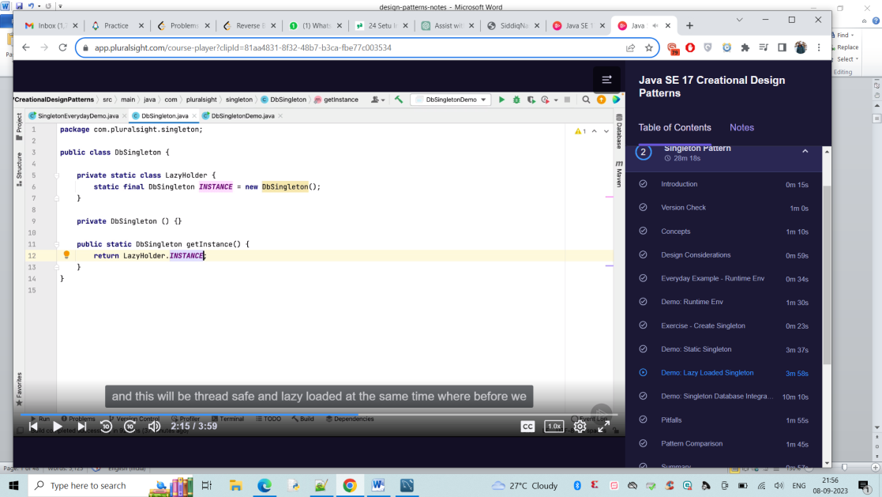

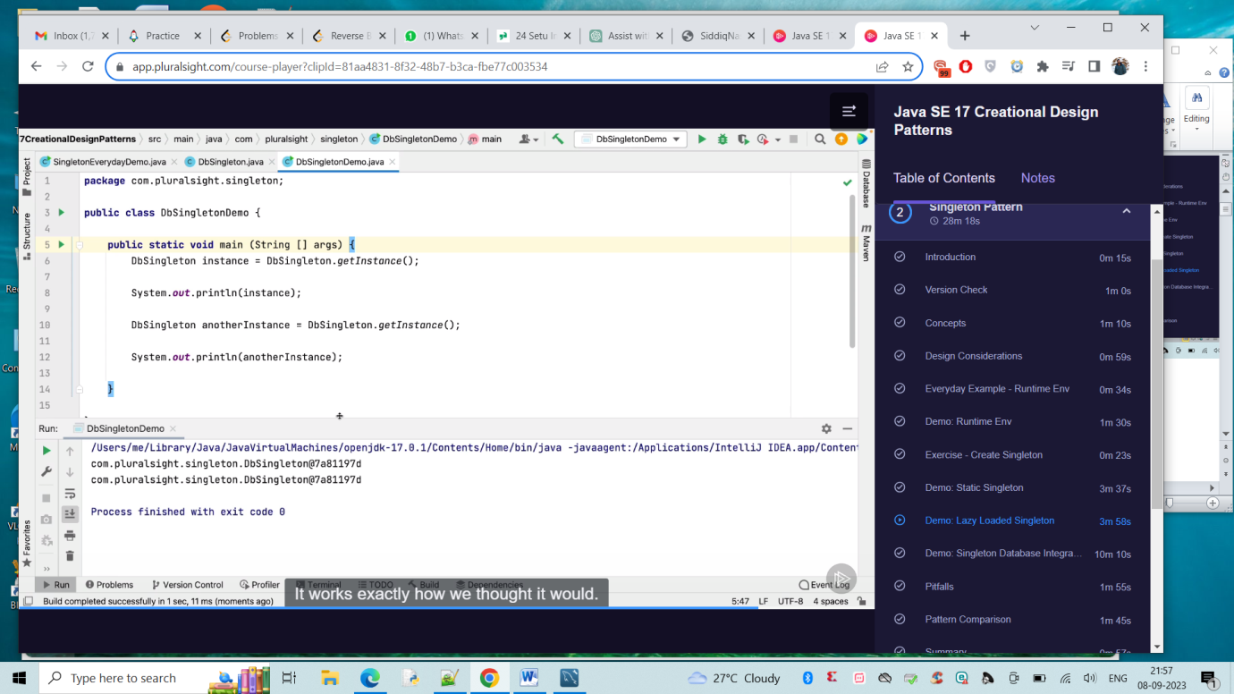

Sample Code:

public class DateUtil implements Serializable,Cloneable {

private static final long serialVersionUID = 1L;

private static volatile DateUtil instance;

private DateUtil() {

}

public static DateUtil getInstance() {

if (instance == null) {

synchronized (DateUtil.class) {

if (instance == null) {

instance = new DateUtil();

}

}

}

return instance;

}

protected Object readResolve() {

return instance;

}

@Override

protected Object clone() throws CloneNotSupportedException {

throw new CloneNotSupportedException();

}

}

Builder Pattern :-

Handles Complex constructors

lots of setters and parameters

API :-

String Builder

Document Builder

Locale.Builder

Creation of different constructors with different parameters is called telescopic constructors.

The builder pattern helps us to overcome this handling the construction within the object rather than by parameters. Can call constructor based on the state. Negates the need for exposing the setters. Since java 1.5 we can take advantage of generics.

STring Builder builder = new STring Builder ();

builder.append("hi");

builder.append("nassar");

Everytime this get calls it appends to already existing one instead of recreating the object. Can refactor in separate class;

Pitfalls :-

Objects created with builder are typically immutable.

-------

The builder pattern is a good choice when designing classes whose constructors or static factories would have more than a handful of parameters.

We've all at some point encountered a class with a list of constructors where each addition adds a new option parameter:

Pizza(int size) { ... }

Pizza(int size, boolean cheese) { ... }

Pizza(int size, boolean cheese, boolean pepperoni) { ... }

Pizza(int size, boolean cheese, boolean pepperoni, boolean bacon) { ... }

**This is called the Telescoping Constructor Pattern.** The problem with this pattern is that once constructors are 4 or 5 parameters long it becomes **difficult to remember** the required **order of the parameters** as well as what particular constructor you might want in a given situation.

One **alternative** you have to the Telescoping Constructor Pattern is the **JavaBean Pattern** where you call a constructor with the mandatory parameters and then call any optional setters after:

Pizza pizza = new Pizza(12);

pizza.setCheese(true);

pizza.setPepperoni(true);

pizza.setBacon(true);

**The problem here is that because the object is created over several calls it may be in an inconsistent state partway through its construction.** This also requires a lot of extra effort to ensure thread safety.

**The better alternative is to use the Builder Pattern.**

public class Pizza {

private int size;

private boolean cheese;

private boolean pepperoni;

private boolean bacon;

public static class Builder {

//required

private final int size;

//optional

private boolean cheese = false;

private boolean pepperoni = false;

private boolean bacon = false;

public Builder(int size) {

this.size = size;

}

public Builder cheese(boolean value) {

cheese = value;

return this;

}

public Builder pepperoni(boolean value) {

pepperoni = value;

return this;

}

public Builder bacon(boolean value) {

bacon = value;

return this;

}

public Pizza build() {

return new Pizza(this);

}

}

private Pizza(Builder builder) {

size = builder.size;

cheese = builder.cheese;

pepperoni = builder.pepperoni;

bacon = builder.bacon;

}

}

Note that **Pizza is immutable and that parameter values are all in a single location**. Because the Builder's setter methods return the Builder object they are **able to be chained**.

Pizza pizza = new Pizza.Builder(12)

.cheese(true)

.pepperoni(true)

.bacon(true)

.build();

**This results in code that is easy to write and very easy to read and understand.** In this example, the **build method could be modified** to check parameters after they have been copied from the builder to the Pizza object and **throw an IllegalStateException if an invalid parameter value has been supplied.** This pattern is flexible and it is easy to add more parameters to it in the future. It is really only useful if you are going to have more than 4 or 5 parameters for a constructor. That said, it might be worthwhile in the first place **if you suspect you may be adding more parameters in the future.**

Prototype :-

Avoids costly creation

Avoid Subclassing

Typically doesnt use "new"

often utilizes interface

clone/cloneable

API :-

Object.clone();

Although unique each instance is unique

shallowcopy(stores references and changes made will be relected in original object) vs deepcopy(copies objects value and doesnt reflect changes made to new object)

Factory :-

Opposite of singleton - arguments in constructor

Doesn’t expose instantiation logic

Common interface

specified by architecture and implemented by user

Concrete classes

The factory design pattern is used when we have a superclass with multiple sub-classes and based on input, we need to return one of the sub-class.

API:-

Calender -> specific type of factory. Some people think it doesnt have parameters in the constructor and hence singleton, But it can have arguments. Calender can return different subclasses .

valueOf method

Resource Bundle

Number Format

Factory is responsible for lifecycle

Its parameter driven

Solves complex creation

Can choose which object to create at runtime

Opposite of singleton(which as default constructor with no parameters)

A factory pattern is a creational pattern that abstracts or hides the object creation process. When you think of factory you can think of a car factory a chocolate factory or a toy factory.A car factory is responsible for manufacturing the cars .A car dealer need not worry about how the car is manufactured. He simply asks the car factory to deliver him some cars. The car factory is responsible for manufacturing them and delivering them to the dealer.

Similarly the Chocolate Factory delivers different types of chocolates based on what the chocolate store asks them to deliver.

An example from the JDBC space when we use different databases like Oracle, MySql, SqlServer. In Java we use something called JDBC driver to connect to a database.

Driver is an interface in the JDBC API and the implementation for this driver is provided by different vendors. The responsibility of the driver is to connect to a particular database and execute sql statements against it.

To get a connection we need not remember each and every driver in how it works. For example if we want to connect to Oracle you need not deal with the Oracle driver and same for other databases.

You simply use DriverManager which is a class in the JDBC API to get connection and you pass in a connection string which is specific to a particular database where it is different for mysql, it's different for sql server.

The driver manager acts as a factory and it will return the connection for us by using the appropriate driver for Oracle it will use Oracle driver for my sql it will use the my sql driver and so on.

It hides all the details of finding a driver and creating a connection against the database for us. So give it a string it will give you a connection. So here the get connection is a static method on the factory class.

We need not create the instance of the driver manager to create objects of type connection.

We simply use the static method on the factory class and get the object we need.

UML:

Another example is a pizza store .A pizza store delivers different types of pizzas.We will a parent interface which is implemented by the veg pizza cheese pizza and meat pizza.The pizza store need not worry about how to create each of these pizzas.It simply asked the pizza factory to deliver the type of pizza it wants or to create a type of pizza it wants.so that it can give it to the customer or it can deliver it to the customer.The pizza factory hides the complexity of creating the different types of pizzas from the pizza store.

Sample Code:

public class PizzaFactory {

public static Pizza createPizza(String type) {

Pizza p = null;

if (type.equals("cheese")) {

p = new CheesePizza();

} else if (type.equals("chicken")) {

p = new ChickenPizza();

} else if (type.equals("veggie")) {

p = new VeggiePizza();

}

return p;

}

}

Abstract Factory:-

API :- DocumentBuilder Factory in XML Parsing

Now that you have mastered the Factory design pattern learning and implementing the Abstract Factory pattern will be quite easy because an abstract factory is a factory of factories.That is a factory pattern was hiding the details of object creation and factory of factories or an abstract factory.hides the creation of the factory itself.

A good example in the Java space is the JAXP API . JAXP stands for Java API for xml parsing . Using this API we can read or write and update the elements in a xml file the key class in this API is the document class that represents a xml document in memory to create a document class.We use that document builder.So this document builder is a factory class and there is one more class document.Build a factory which is responsible for creating the document builder itself.So the document builder factory is a abstract factory because it is a factory of factories and the use case you are going to work on to give you

Another example is a DAO factory. DAO stands for data access object.We'll learn more about it in sections later on.It simply is a class that can read write create update data we can have different types of DAO'sDAO's that deal with xml data and DAO's that deal with DB data and within xml we can have employee information department information.

Similarly within that database we can have employ information and department information.So you can see that we can have a factory to deal with these separate DOA's we can have a DB DAO factory that can give us one of these classes here when our application needs them and we can have a xml DAO factory which can give one of the classes here.Now to get one of these factories themselves these factories will first implement a DAO abstract factory or they will extend DAO abstract factory class and we will have a producer which is responsible for creating one of these factories so abstract factory is a factory off factories.

It simply creates the factory we need. when we have multiple factories we see in our application.

UML:

Sample Code:

public class DaoFactoryProducer {

public static DaoAbstractFactory produce(String factoryType) {

DaoAbstractFactory daf = null;

if (factoryType.equals("xml")) {

daf = new XMLDaoFactory();

} else if (factoryType.equals("db")) {

daf = new DBDaoFactory();

}

return daf;

}

}

--------------------------------------------------------------------------------

Structural Design Patterns :-

<https://refactoring.guru/design-patterns/structural-patterns>

Structural design patterns explain how to assemble objects and classes into larger structures, while keeping these structures flexible and efficient.

Adapter:-

Connecting new code to legacy code or Adapting an interface into another according to client expectation.

API :-

Collection APIS Arrays(legacy and original)-> List(Introduced later)

Streams (can work with another type of streams as well)

Design:-

Client Centric

Integrate new with old

implemented with Interface, but not required

Adatpee can be new portion of code

UML :-

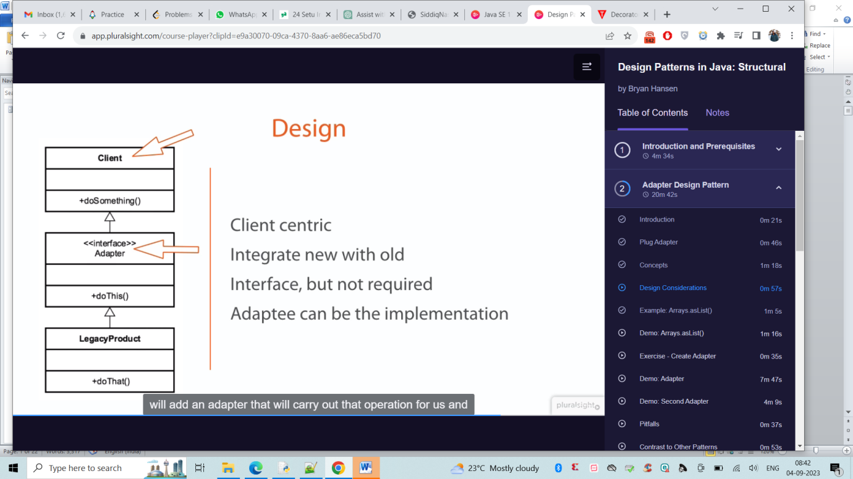

LegacyProduct -> DoSomething(interface ) Adapter -> DoSomethingClass(new)

Target (Interface) Client uses this <-> AdapterClass() <-> Adaptee class(Existing code)

Adapter class implements Adaptee class and extends target interface.

Client class will call Adapter class

If you have used a power adapter then you already know what an adapter pattern is .The job of a power adapter is to adapt it to a particular location and a particular switchboard.For example the same laptop plug pins that work in USA will not work in UK and in India.We will have to use appropriate power adapter that can take our laptop pins into it and on the other side of it it will have pins that can go into the local countries switchboard and it can also adapt to the appropriate range in that country.

Similarly in the world of programming when we have two applications communicating with each other or two objects using each other and one object invokes the method of another object.Then we have to adapt in some cases.

For example here we have a WeatherFinder class which has a findWeather. By passing in a city you can get the weather and we have an implementation of it which will return the weather back and there is a UI class that wants to use the weather finder . But the UI only knows the zip code of the city. It does not have the city information it only has the zip code but it wants to get the weather of it.

That is where an adapter comes in. We will implement an adapter which will take the zip code. The weather UI will invoke the findTemperature Method on the WeatherAdapter it will pass in the zip code. The weather adapter is responsible for looking up for the appropriate city that matches the zip code and hen invoke the weather finder, take the results and return the results back to the weather UI. So it exactly acts like a power adapter. It takes the inputs from the class that wants to use another class because the inputs here are different from what the other side of the relationship expects.

public class WeatherAdapter {

public int findTemperature(int zipCode) {

String city = null;

if (zipCode == 19406) {

city = "King Of Prussia";

}

WeatherFinder finder = new WeatherFinderImpl();

int temperature = finder.find(city);

return temperature;

}

}

Bridge Design pattern :-

Same like Adapter pattern, bridge works with new code where as adapter works with legacy code

Expect changes on both sides

Designed upfront or built in advance

API :-

Driver

JDBC

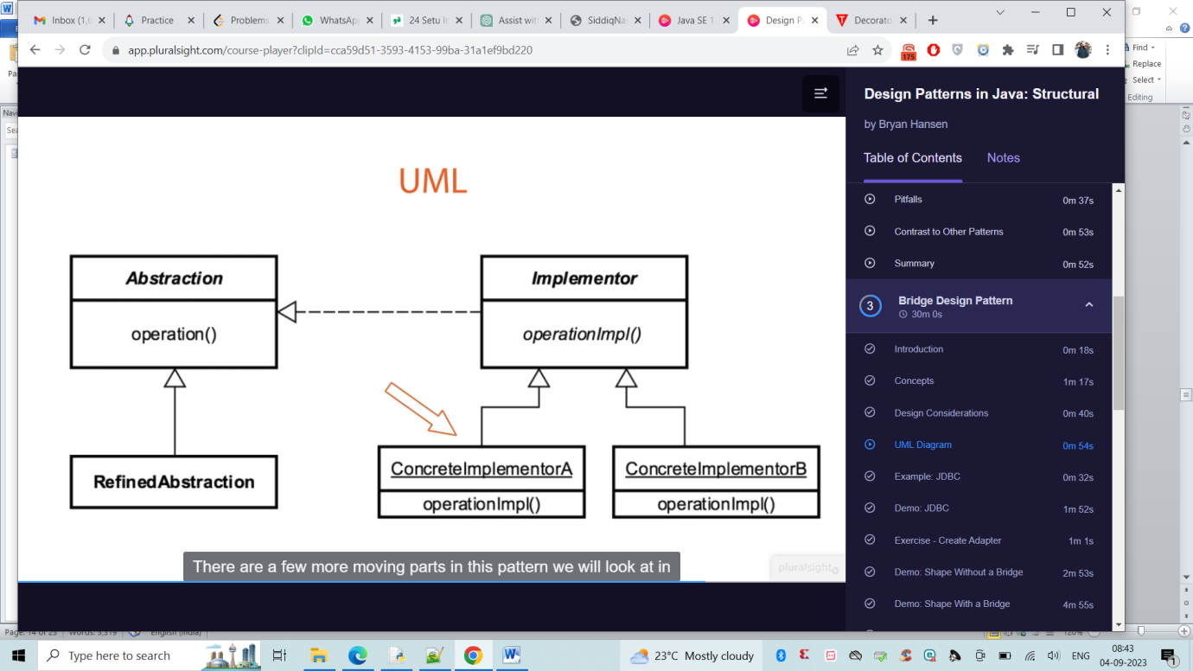

Here example of GreenColour and Red Circle for Circle Shape:-

<https://www.tutorialspoint.com/design_pattern/bridge_pattern.htm>

Decorator:-

Also called a wrapper

add behaviour without affecting others

More than just inheritance

Single Responsibility Principle

Compose behaviour dynamically

API :-

java.io.inputstream

java.util.collections

almost all UI components

Design :-

Inheritance based

Alternative to subclassing

constructor requires instance from hierarchy

UML :-

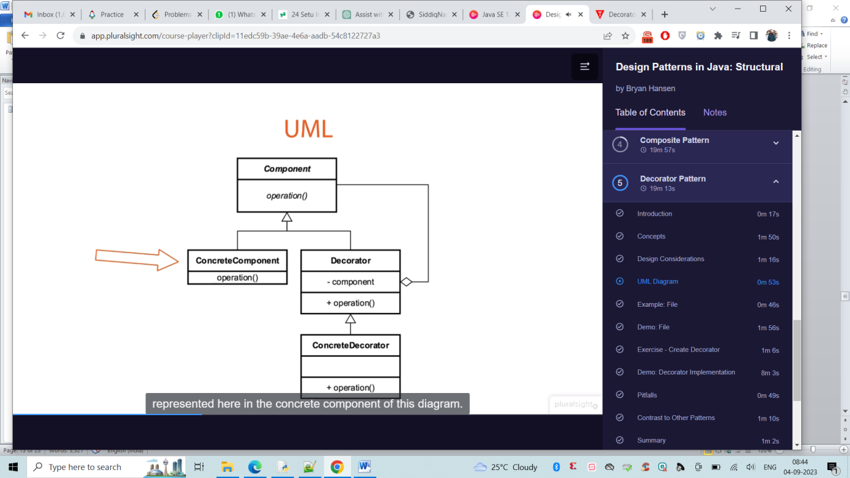

**Step 1:** Creating an interface named ‘Shape’

**Example**

|  |
| --- |
| // Interface named Shape  public interface Shape {      // Method inside interface      void draw();  } |

**Step 2:** Create concrete classes implementing the same interface. Rectangle.java and Circle.java are as follows

**Example**

|  |
| --- |
| public class Circle implements Shape {      @Override      public void draw()      {          System.out.println("Shape: Circle");      }  } |

**Step 3:** Create an abstract decorator class implementing the Shape interface.

**Example**

|  |
| --- |
| // Class 2  // Abstract class  // ShapeDecorator.java  public abstract class ShapeDecorator implements Shape {      // Protected variable      protected Shape decoratedShape;      // Method 1      // Abstract class method      public ShapeDecorator(Shape decoratedShape)      {          // This keywordd refers to current object itself          this.decoratedShape = decoratedShape;      }      // Method 2 - draw()      // Outside abstract class      public void draw() { decoratedShape.draw(); }  } |

**Step 4:** Create a concrete decorator class extending the ShapeDecorator class.

**Example**

|  |
| --- |
| // Class 3  // Concrete class extending the abstract class  // RedShapeDecorator.java  public class RedShapeDecorator extends ShapeDecorator {      public RedShapeDecorator(Shape decoratedShape)      {          super(decoratedShape);      }      @Override public void draw()      {          decoratedShape.draw();          setRedBorder(decoratedShape);      }        private void setRedBorder(Shape decoratedShape)      {        // Display message whenever function is called          System.out.println("Border Color: Red");      }  } |

**Step 5:**Using the RedShapeDecorator to decorate Shape objects.

**Example**

|  |
| --- |
| // DecoratorPatternDemo.java  public class DecoratorPatternDemo {      // Main driver method      public static void main(String[] args)      {          // Creating an object of Shape interface          // inside the main() method          Shape circle = new Circle();            Shape redCircle              = new RedShapeDecorator(new Circle());            Shape redRectangle              = new RedShapeDecorator(new Rectangle());          // Display message          System.out.println("Circle with normal border");          // Calling the draw method over the          // object calls as created in          // above classes          // Call 1          circle.draw();          // Display message          System.out.println("\nCircle of red border");          // Call 2          redCircle.draw();          // Display message          System.out.println("\nRectangle of red border");          // Call 3          redRectangle.draw();      }  } |

**Step 6:** Verifying the output

**Output:**

Circle with normal border

Shape: Circle

Circle of red border

Shape: Circle

Border Color: Red

Rectangle of red border

Shape: Rectangle

Border Color: Red

Pitfalls :-

New class for every feature

multiple little objects

people confused with inheritance

Can be more complex for clients

A decorator pattern is a Structural pattern that adds additional functionality to an object dynamically at runtime. A decorator wraps an object with additional behaviour without affecting other objects of the same type. The classes in the input output streams in Java use the decorator pattern to read and write files.

For example lets consider a pizza shop. We have a pizza and we have a base pizza. A plain pizza, pizza by itself doesn't mean anything it is very abstract. A plain pizza probably it is just the dove without any cheese or veggies or any meat on it. And now when the client wants a plain pizza or he can ask for a veggie pizza or a cheese pizza or meat pizza

At runtime we can dynamically add all these toppings using a pizza decorator as required. A pizza decorator will be implemented by veggie pizza decorator and a cheese pizza decorator. Each of these bring in additional functionality. So if the client asks for a veggie pizza we are going to use the veggie pizza decorator at run time.

The client ask for a cheese pizza. We can ask the cheese pizza decorator to decorate the plain base pizza with cheese and with veggies as required. The pizza here is the component the plain pizza is a concrete or a base component. The decorator is the pizza decorator and these two are concrete decorators. Both the veggie pizza decorator and the cheese pizza decorator are called concrete decorators so you are going to implement all of that in the next few lectures.

Sample Code:

public class PizzaShop{

public static void main(String args[]){

Pizza pizza = new VeggiePizzaDecorator(new CheesePizzaDecorator(new PlainPizza()));

}

}

Facade pattern :-

Provides simplified interface to complex implmentation

Makes an API easier to use

Reduce dependencies on outside code

API :-

Java.net.URL -> its is a(Complex api)

Javax.faces.context.FacesContext

Design :-

Shouldn’t have a need for inheritance

Typically encompasses full lifecycle

UML :-

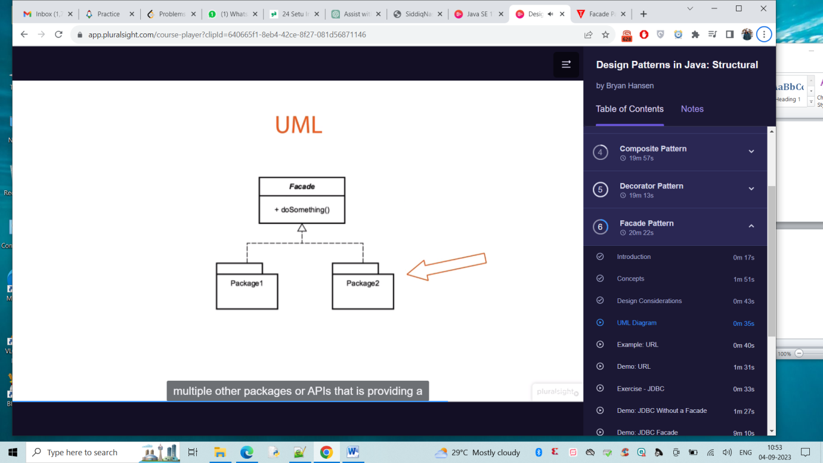

Code :-

URL url = new URL(“http”, “pluralsight.com”,80, “/author/nassar”)

Buffered in = new BufferedReader(new InputsStreamReader(url.openStream()))

PIT Falls :-

Typically used to clean up the code

Refactoring Pattern

Should think about API design (Easy pattern to implement just copy paste and add same functionality )

Flat problem/structure

The “singleton” of Structural pattern

* People use this to hide the complexity and worst complex backend code

Flyweight :

More Efficient use of memory / Great for memory Manager

Large Number of similar objects

Immutable & A little bit of complex

Used a lot by the Core API

API:-

Java.lang.String

Java.lang.Integer#valueOf(int)

Wrappers such as Boolean,Byte,Character,Short,Long

Design :-

Its Complicate as its pattern of patterns

Utilizes a Factory

Encompasses Creation and Structure

UML:-

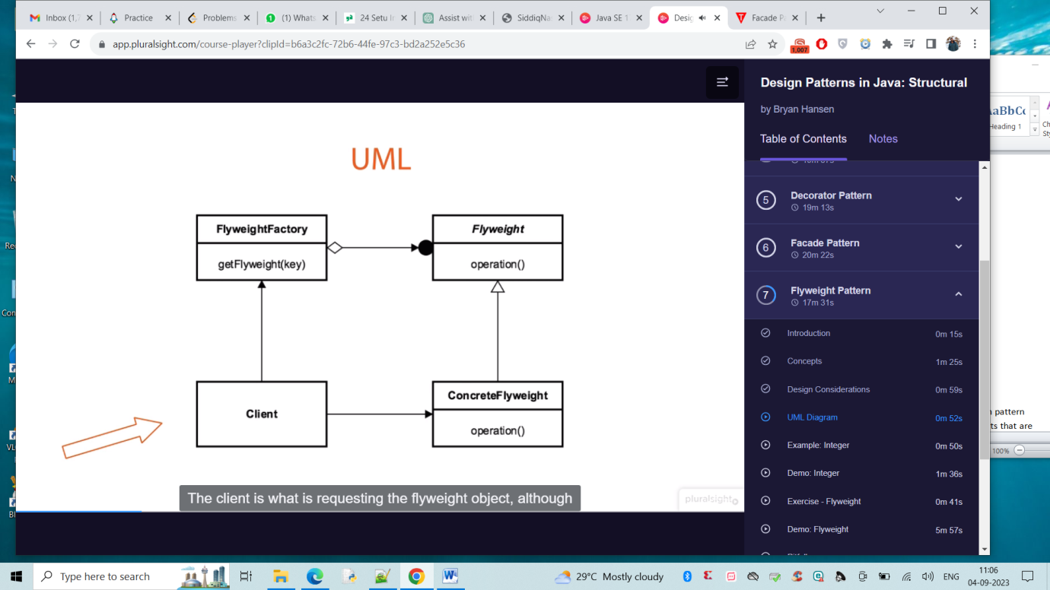

Explanation:-

Here Client will ask getFLightWeight(key) from flyWeightFactory and then flyweightFactory will look into the flightweight and instance is not created it will create using concreteFlyWeight and client gets from Concrete FlyWeight . Client is not aware of whats happening inside and it saves memory.

Code :-

Integer first = Integer.valueOf(5);

Integer second = Integer.valueOf(5);

Integer third = Integer.valyueOf(9);

Sysout(System.identityHashCode(first));

Sysout(System.identityHashCode(second));

Sysout(System.identityHashCode(third));

o/p:-

1995649664

1995649664

4456787678

Pitfalls:-

Complex pattern

Premature Optimization and Must understand Factory

Not a graphical Pattern

A flyweight design pattern can be used to save memory. A flyweight is a structural design pattern instead of creating a large number of similar objects.We can reduce the number of objects that are created by reusing the objects and saving memory. Memory is a huge concern especially when it comes to mobile applications with limited memory.

Let's say we are working on a paint app that allows users to draw different shapes that is circles and rectangles.

Here we have a shape interface with a draw method on it.

When we have a circle class and the rectangle classes that implements that interface using a circle.

The user can draw a circle using a rectangle of course he can try her rectangle to do that.

He will have to create a circle and assign a radius for each circle he wants to create.

Similarly for each rectangle he will how to set the length and the breadth by creating a separate object by using the flyweight pattern.

You will do all that by creating one single circle and one single rectangle he will see what the problem is he will implement the problem first and then you will resolve that problem of multiple object creation by using the fly design pattern in the next few lectures.

Sample Code:

public class ShapeFactory {

private static Map<String, Shape> shapes = new HashMap<>();

public static Shape getShape(String type) {

Shape shape = null;

if (shapes.get(type) != null) {

shape = shapes.get(type);

} else {

if (type.equals("circle")) {

shape = new Circle();

} else if (type.equals("rectangle")) {

shape = new Rectangle();

}

shapes.put(type, shape);

}

return shape;

}

}

PROXY Pattern :-

Interface by wrapping

Can add Functionality

Secure,Simplicity,Remote,Cost

API :-

Java.lang.reflect.proxy

Java.rmi.*

Used by IOC frameworks

Design:-

Interface based

Interface and Implementation class

Java.lang.reflect.Proxy to facilitate this

Client,Interface,InvocationHandler,Proxy and Implementation

UML:-

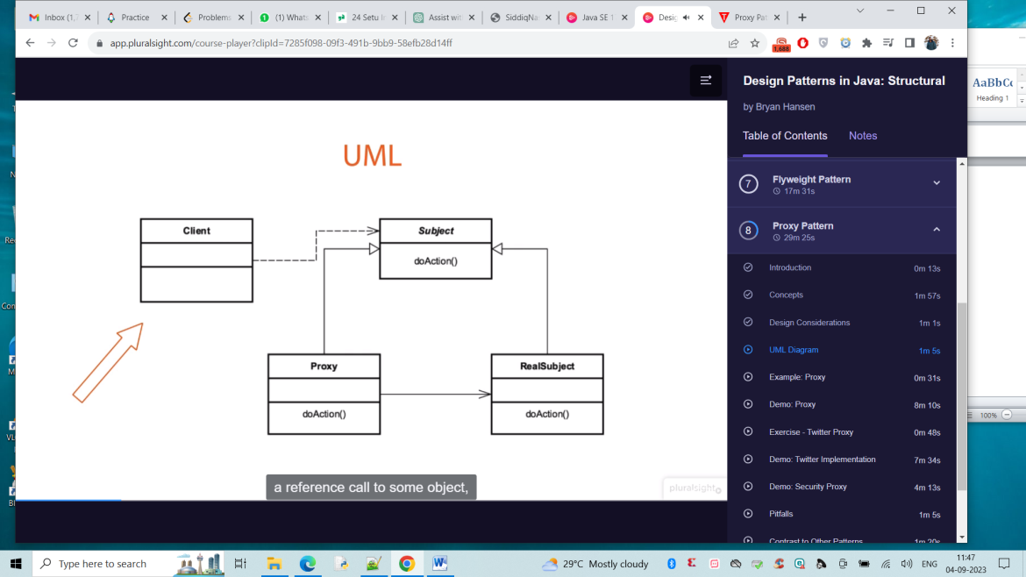

Client class make call to reference class or subject(Interface to implementation class) and then proxy interface that class and makes call to RealSubject or class and checks if needs to load that or from cache and returns that back to client. Here the proxy class implements InvocationHandler.

BEHVAIOURAL Patterns:-

Behavioral design patterns are concerned with **the interaction and responsibility of objects.**

CHAIN OF RESPONSIBILITY :-

Decoupling Sender and receiver

**Chain of Responsibility** is a behavioral design pattern that lets you pass requests along a chain of handlers. Upon receiving a request, each handler decides either to process the request or to pass it to the next handler in the chain.

Receiver contains reference to next receiver (Doesn’t know whole hierarchy but knows next object)

Promotes loose coupling

May or may not be handler

API:-

Java.uti.logging.Logger#log()

Spring Security Filter Chain

Javax.servlet.Filter#doFilter()

Design :-

Chain of receiver Objects

Handler is Interface Based

ConcreteHandler for each Implmenetation

Each handler has reference to next

UML :-

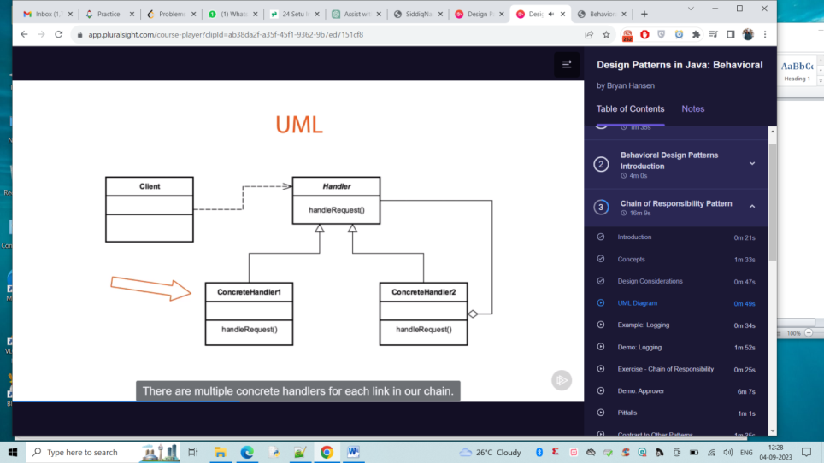

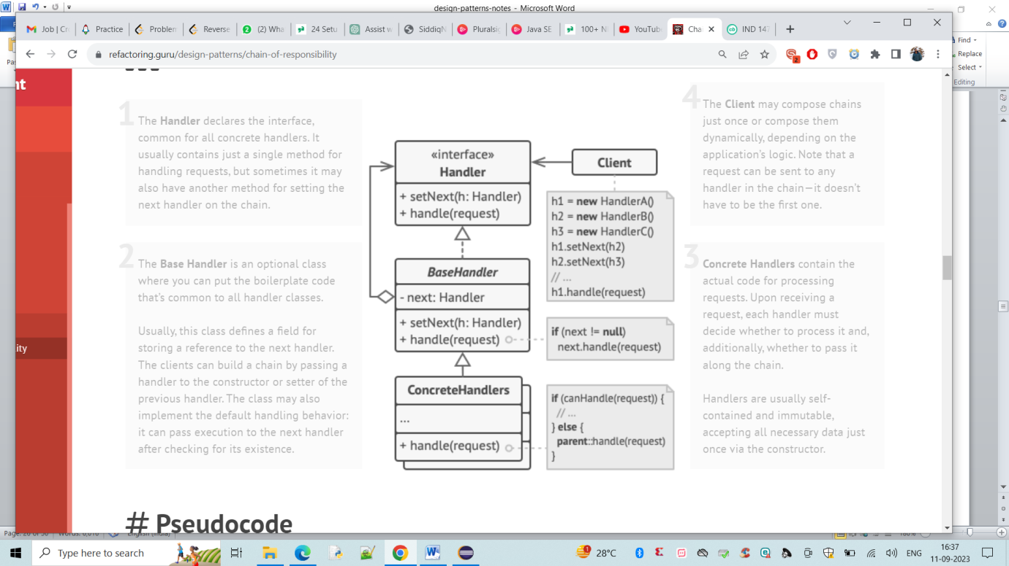

Common Handler and multiple concrete handler.

Even called unknown handler and it shouldn’t exit.

Like logger.finer() and logger.fine() works but logger.finest() even though incode and not present in logger, the code wont exit and it wont be printed too.

PitFalls:-

Handling/Handler gurantee

Runtime configuration risk

Chain length/performance issues

COMMAND Pattern :-

Encapsulates request as an object

Object-Oriented callback

Decouple sender from processor

Often used for “undo” functionality

API :-

Java.lang.Runnable -> Thread creation one

Design:-

Object per command

Command Interface

Execute Method(where all action is performed)

Reflection

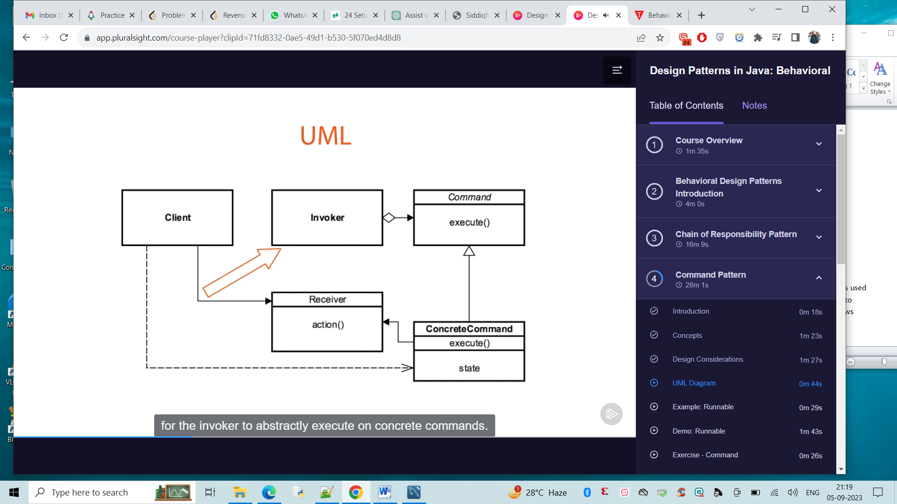

Command Interface is heart of this pattern, provides structure for invoker . The receiver has action method that the execute method is performed on. Abstraction is that client doesn’t call receiver director, as action is decoupled from the client.

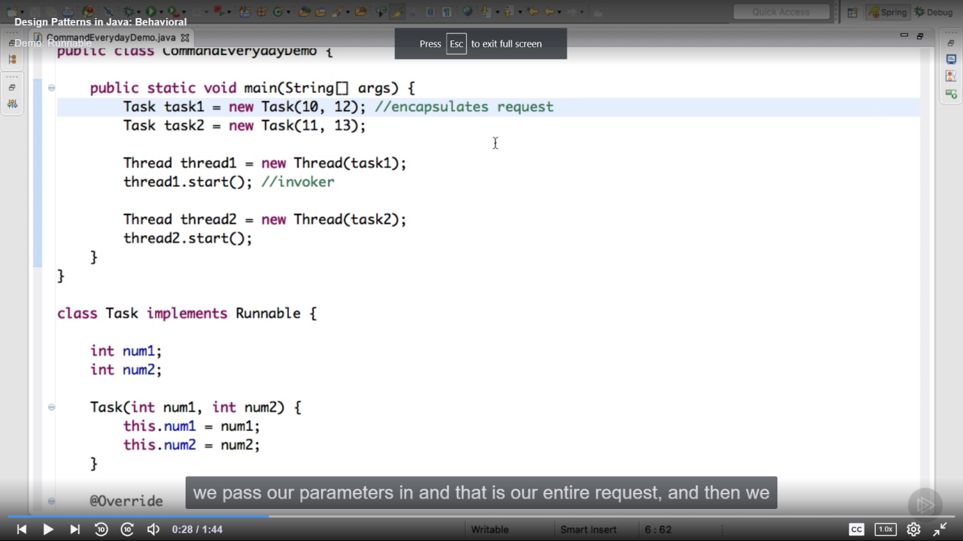

Here invoker start is used.

Pitfalls ;-

Dependence on other patterns

Multiple Commands

Make us of memento

Prototype of copies

Summary :- Encapsulate each request as object , decouple sender from receiver , often used for undo functionality like light/switch on/off.

A command design pattern is a behavioural design pattern from that gang of four patterns. It is used to encapsulate a request as an object and pass it to an invoker the invoker doe not know how to service the request from the client. It will take the command and pass it to a receiver who knows how to perform the action typically.

There are five actors in the command design pattern. They are the command itself. The client the invoker the concrete command that implements the command and a receiver who knows how to perform all the actions.

Let's take a look at an example to see all these five actors in action. Let's consider a person who is using a television or is watching a television and he uses a remote control typically to perform several operations. But let's simply take the on and off operations and let's see how the command pattern fits in here. Here the person is the client who wants to execute the on and off command on it television, the remote control is the invoker so he uses remote control to invoke a particular command by pressing a button and the commands themselves are the on command and off command that implement a interface called Command which has a execute method.

So the person will wrap this on command passes it to the remote control the remote control will send that command to the television and the television knows how to perform that action based on the command that comes in when it is on.

It will execute the command which is passed in which is the on command execute method. And when it is off it will perform the Execute method of the off command to switch off the television.

Here person is the client remote control is the Invoker command is the command interface on command and off command are the concrete command classes. And finally television is the receiver who knows how to perform the action. The huge advantage of the command pattern is that the invoker which is the client and the remote control are completely decoupled from the receiver.

The person need not touch the television or he need not know how to perform the on and off command he simply uses the remote control and presses the button the remote control also doesn't care how the actions are performed. It simply passes the command to the television. That way they are completely decoupled the invoker does not know the details of the action that needs to be performed.

The receiver here the television can change the implementation of how the on and off should be performed without impacting the remote control and the person.

Sample Code:

public class RemoteControl{

private Command command;

public void pressButton(){

command.execute();

}

}

Interpreter Pattern:-

Represent grammer -> mathematical equations, music notation

Interpret a sentence / Special case pattern

Map a domain

AST -> Abstract syntax tree

Functions are defined s methods

Adding new functionality changes to every variant

API:-

Java.util.Pattern

Java.text.format

Design :-

Abstract Expression -> declares an interface to execute operation

Interpret

Terminal Expression -> leaf of tree

NonTerminalExpression -> compound expressions.

UML :-

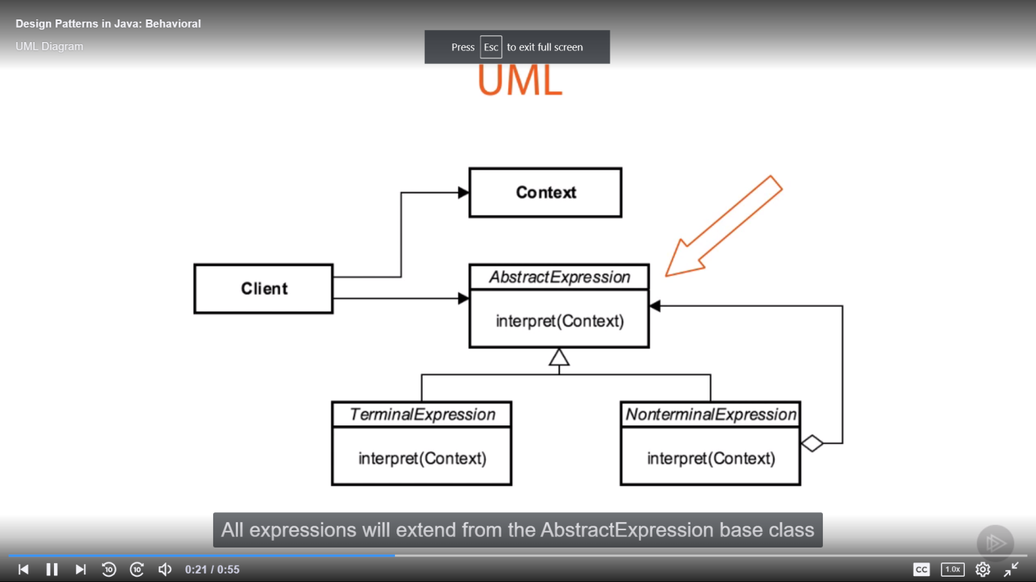

Client builds sentence of terminal and nonterminal expression. Context contains information g;lobal to interpreter. AbstractEXpression base class Provides contract for how we interact with one another. Terminal Expressions that can be evaluated in current form. Non terminal expression can be interpreted again. You can see loop back to abstractexpression recursively broken to terminal expression.

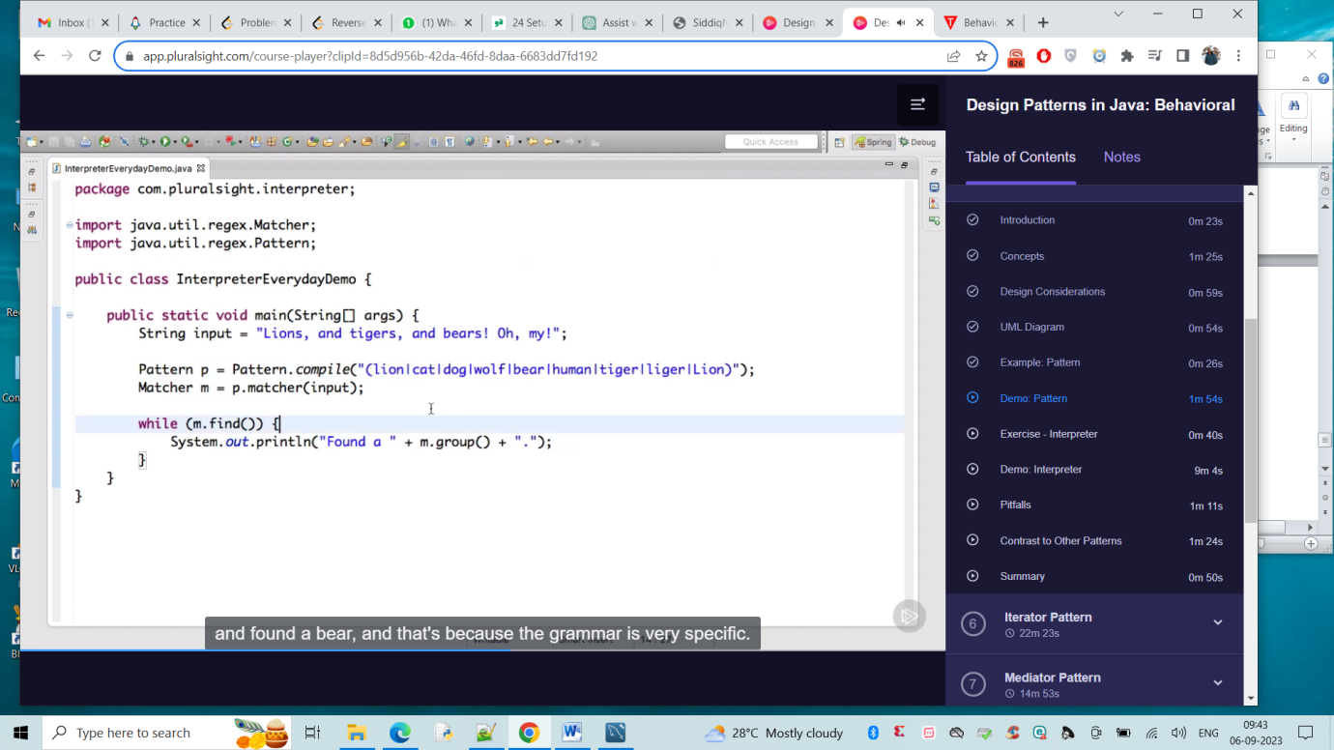

O/p:- Found a tiger

Found a bear

Found a Lion

Pitfalls :-

Complexity -> If grammer becomes very complex, difficult to maintain

Class per Rule -> Maintainance

Use of other patterns

Specific case

Iterator Pattern:-

**Iterator** is a behavioral design pattern that lets you traverse elements of a collection without exposing its underlying representation (list, stack, tree, etc.).

Traverse a Container

Doesn’t expose underlying structure

Decouples algorithm

Sequential in nature

Efficient way to traverse & hide algorithm.

Simplify client

**Use the Iterator pattern when your collection has a complex data structure under the hood, but you want to hide its complexity from clients (either for convenience or security reasons).**

API :-

Java.util.iterator -> can iterate all of our containers and collections

Java.util.Enumeration

Design :-

Interface Based

Follows sort of factory Method based.

Each iterator is built in a Independent way , but fail fast.

Enumerators are fail safe.

UML :-

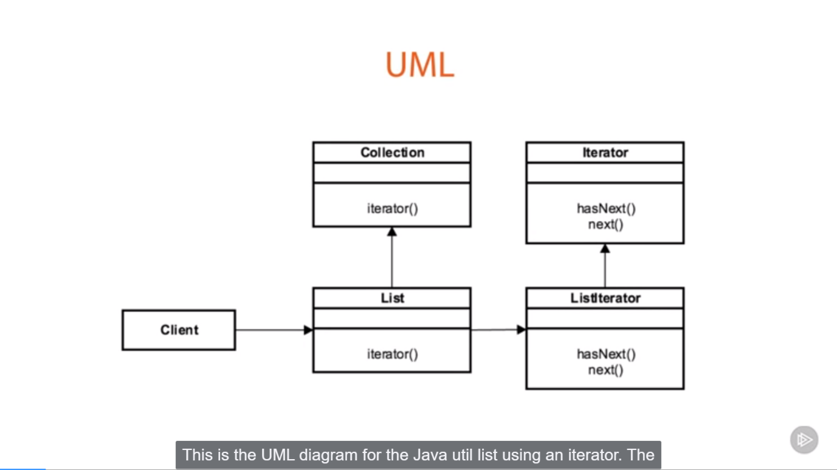

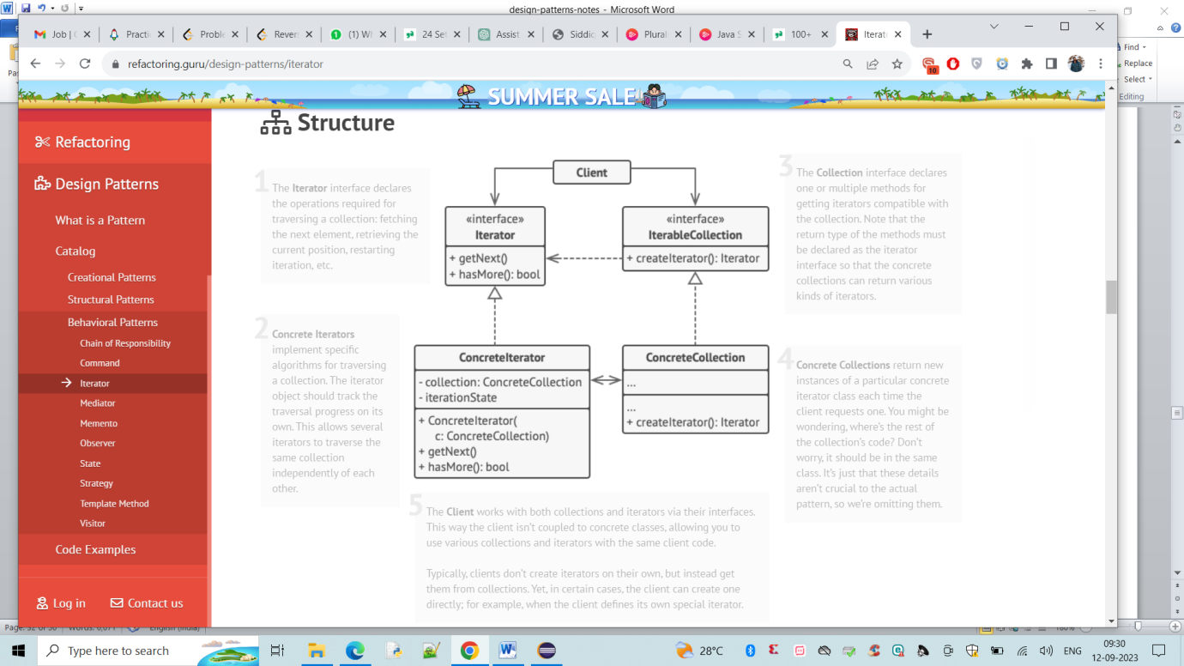

List iterator is implementation of iterator interface that understands how to iterate over the list objects in collection API.

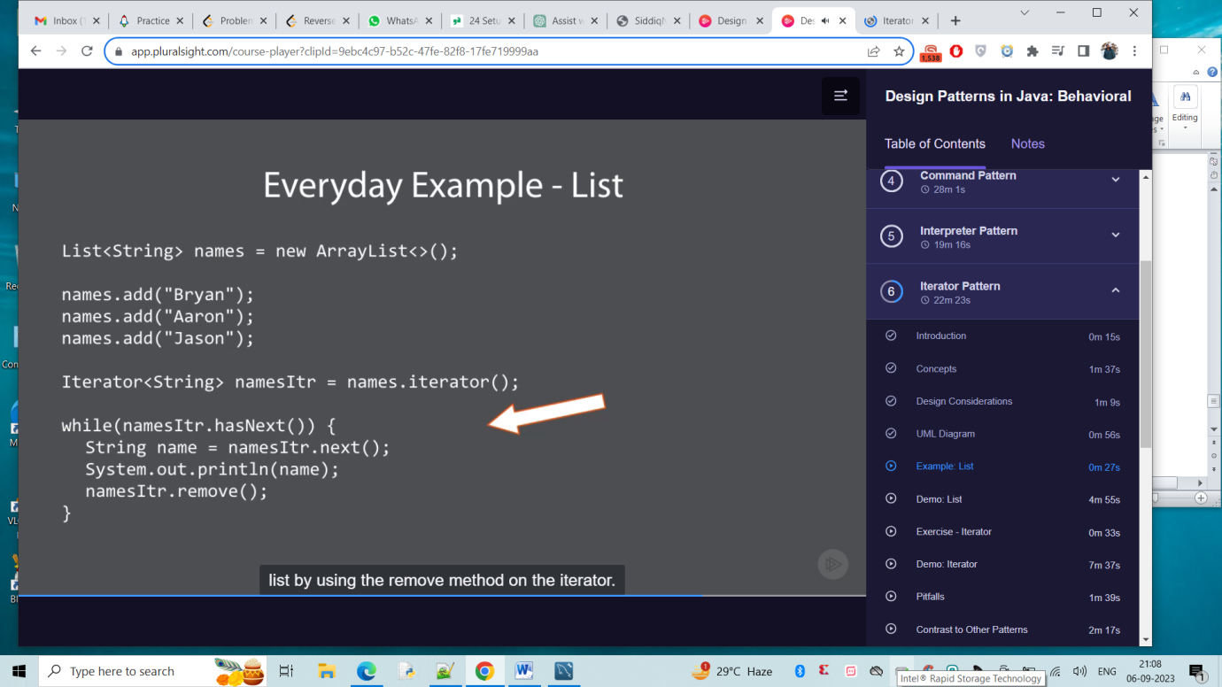

Pitfalls :-

No Access to index

Unidirectional -> Some of them can be forward or backward

Speed/efficiency (large loops iterator can be better to go through large collections)

Mediator Pattern:-

**Mediator** is a behavioral design pattern that lets you reduce chaotic dependencies between objects. The pattern restricts direct communications between the objects and forces them to collaborate only via a mediator object.

Loose Coupling

Well defined but complex

Reusable Components

Hub/Router -> all communciations are routed through

Defines Interactor & More Specific & Simplified Communicator

API :-

Java.util.Timer

Java.lang.reflect.Method#invoke()

Design :-

Interface based

Concrete class

Minimizes inheritance

Mediator knows about colleagues

UML :-

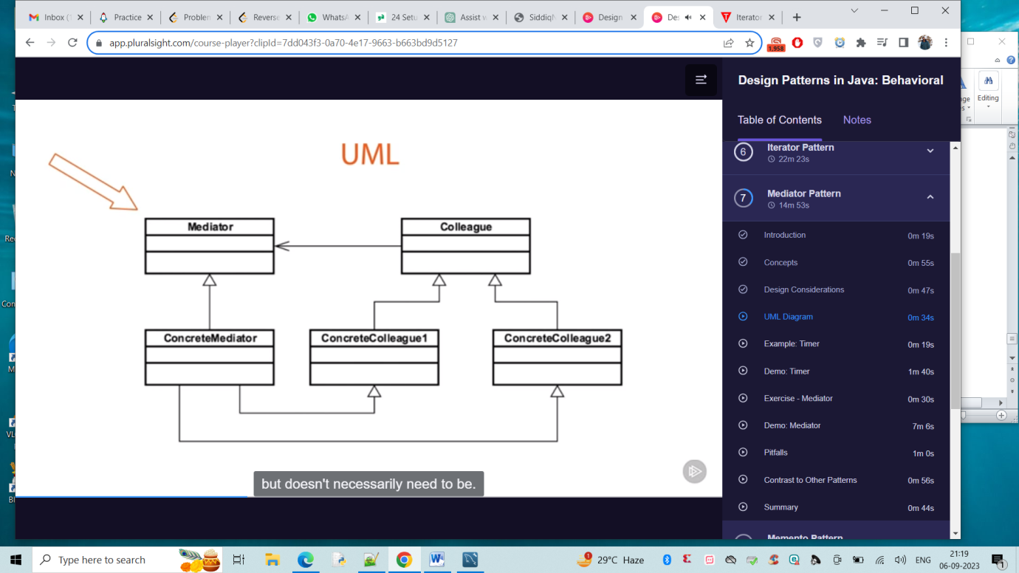

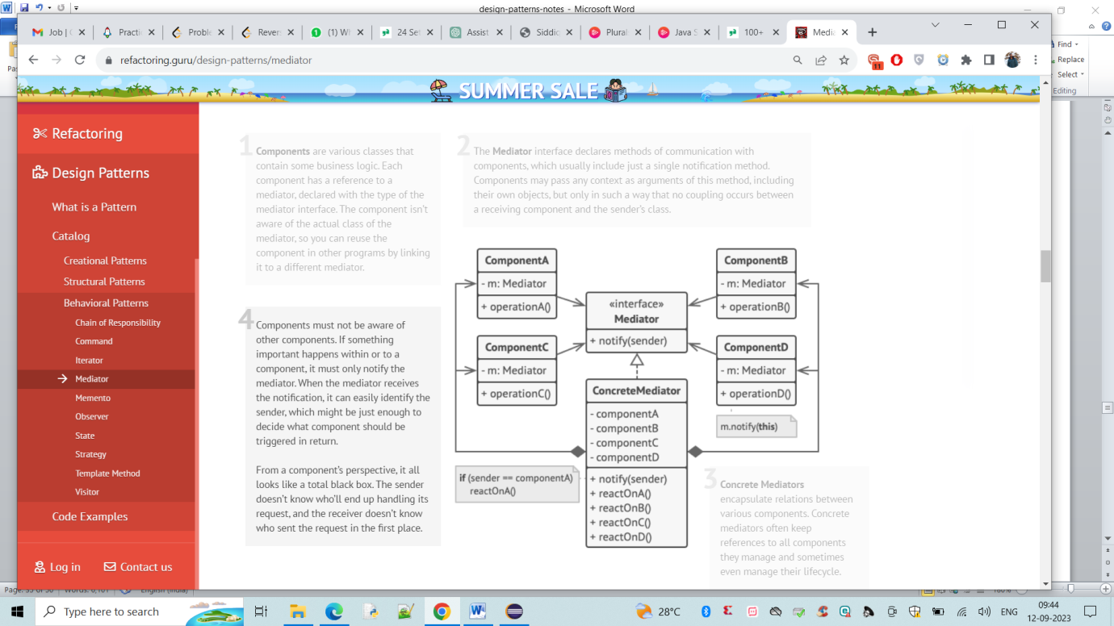

Mediator class is interface or abstract (doesn’t need to be) or the functionality can extend.These colleagues will not be communicated one another but rather through mediator.

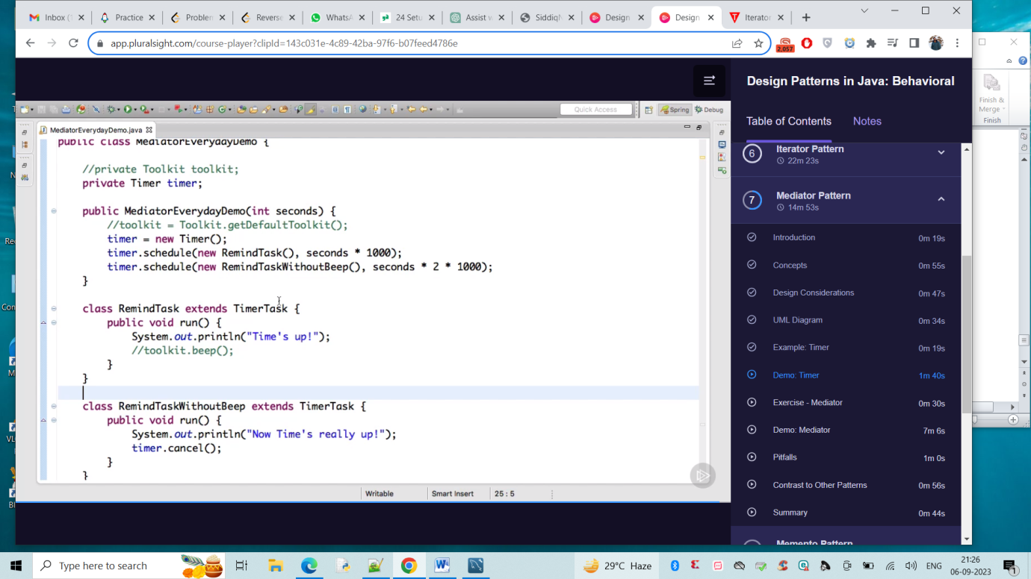

O/P:-

About to schedule a task

Task Scheduled

After some one more comes

Time’s up!

Again after sometime

Now Time’s really up!

Pitfalls :-

Deity Object _.

Limits subclassing

Over or with command -> conjunction with command pattern

Memento Pattern :-

**Memento** is a behavioral design pattern that lets you save and restore the previous state of an object without revealing the details of its implementation.

Restore Object to previous State can be achieved by Externalizing internal state

Undo/rollback functionality

Shields Complex internals

Captures state & Each state captured is independent

Focused on building history

API :-

Java.util.Date

Java.io.Serializable

Design :-

Class Based

Originator

Caretaker -> Manages type copies of mementos we created

Memento -> represents of copy of originator

Magic Cookie -> combination of fields that it takes to recreate or copy and stores inside memento

UML :-

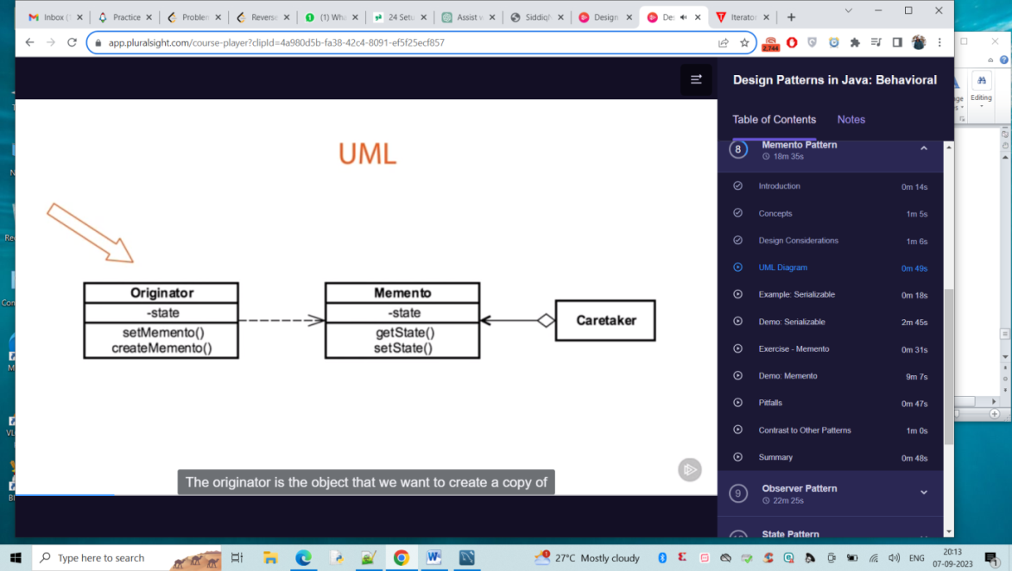

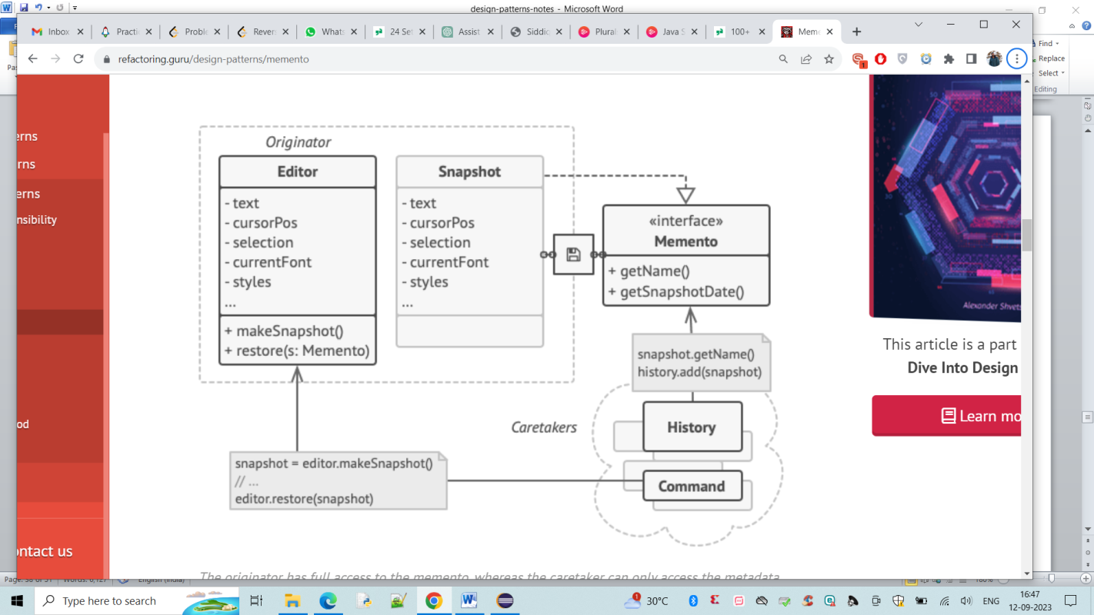

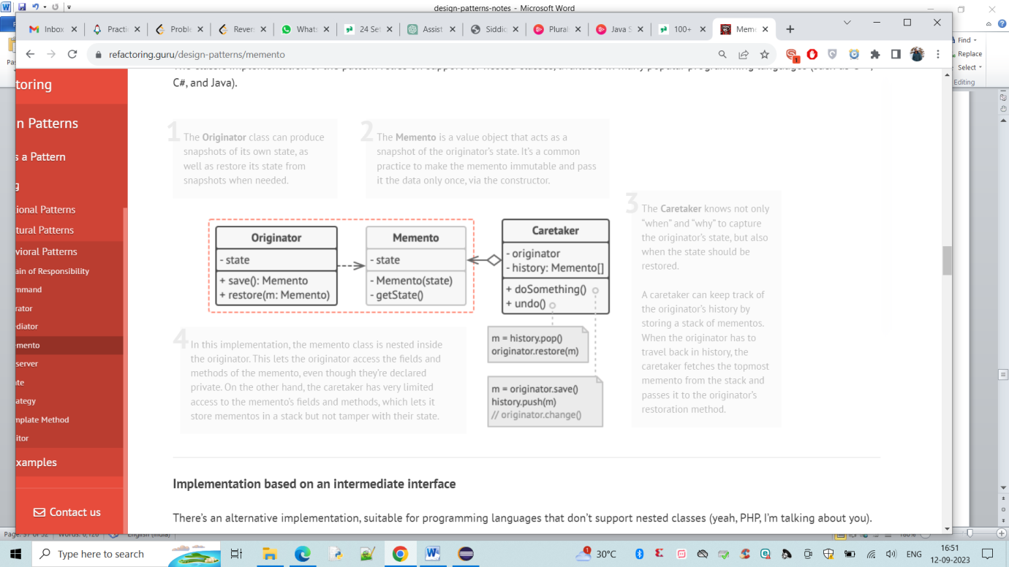

Originator -> is the object that we want to create an object/return to the state.

Memento :- Ability to set the state or create a memento of itself. Has state as well and methods to access as well

Caretaker :- The copies of memento will be saved in caretaker. Caretaker knows why and when this originator needs to be saved and how to restore itself. It’s like a stack where we create it and save and revert can revert back the history too.

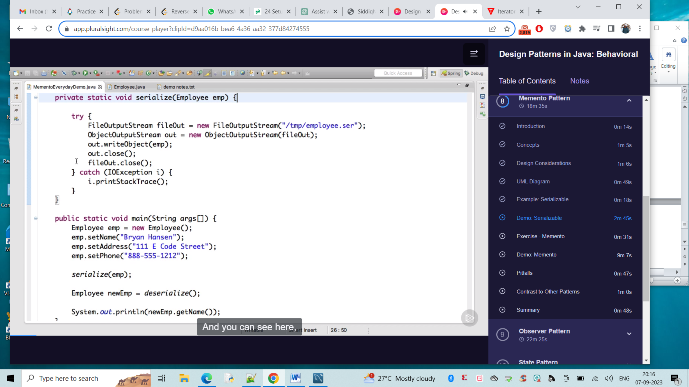

We serialize to store to file and an deserilaize back where employee class implements Seriliazable. Seraialize method uses FileOutputStream to write to object.

Pitfalls :-

Can be expensive if object is too large to store

Caretaker should consider deletes/history and all

Shouldnot expose information

Observer Pattern :-

**Observer** is a behavioral design pattern that lets you define a subscription mechanism to notify multiple objects about any events that happen to the object they’re observing.

Situation when subject is One to many Observers

Decoupled object

Event Handling Capabilities

Pub/Sub Model or broadcast Communication

MVC

API :-

Java.util.Observer

Java.util.EventListener -> Base interface where virtually any evenet listener in AWT abd Swing

Javax.jms.Topic

Design :-

Subject -> which needs to be observed

Observer -> Interface based which has concrete implementations

Observable -> Subject implements Observable interface

Views are observers

UML:-

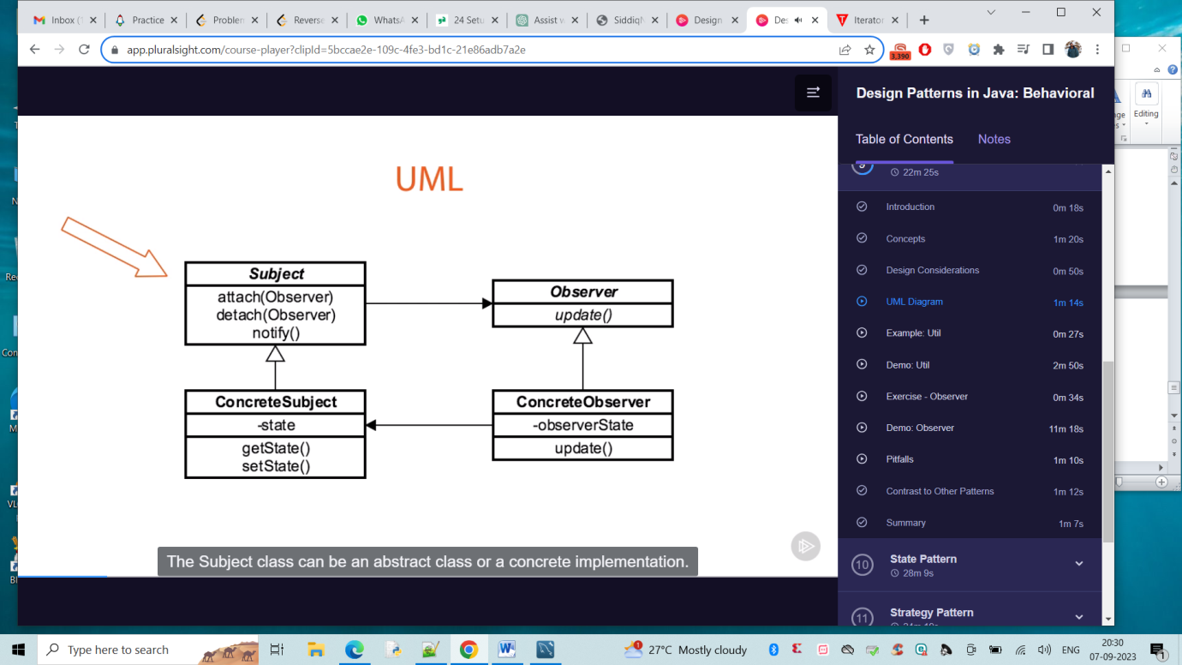

The subject class can be abstract or concrete implementation,The attach and detach methods are to register methods for notifications. The notify method cycle through each registered Observer, calling its update method.

The concrete subject is an implementation of subject. Contains state of the Observers wanting to be notified.The observer interface contains one method, update method that gets called when something changes in the subject and the issue gets notified.

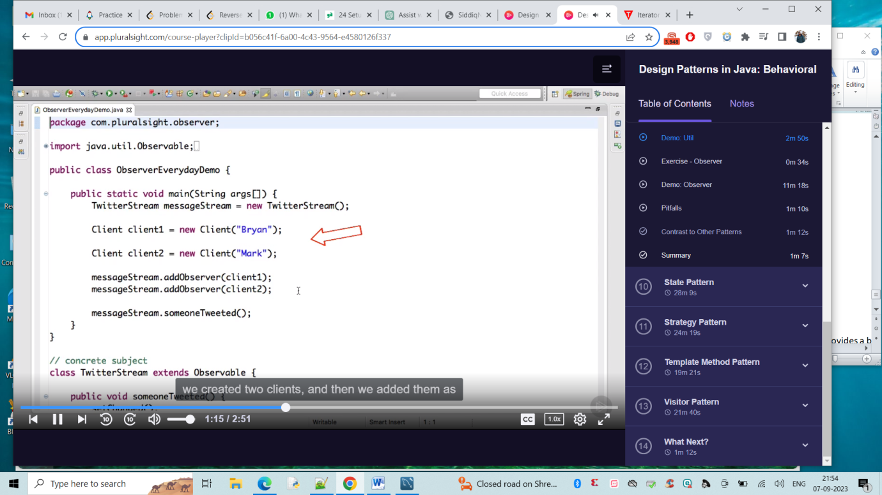

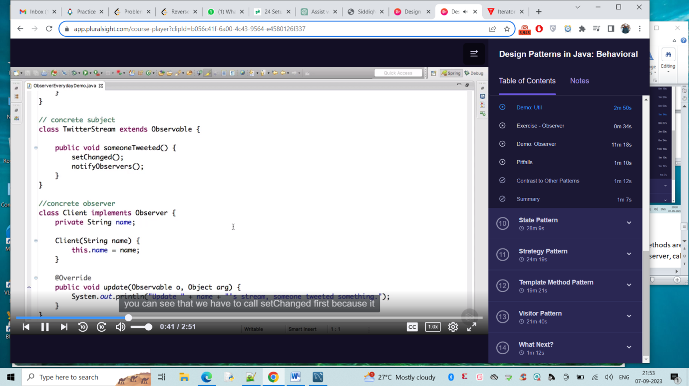

Pitfalls :-

Unexpected updates

Large sized Consequences -> Something like a file update everytime

Not knowing whats changed -> in large projects

As connected nature, debugging difficult

State Pattern :-

**State** is a behavioral design pattern that lets an object alter its behaviour when its internal state changes. It appears as if the object changed its class.

Localise state behaviour

Current state stored in object rather than variables

Separates what state we are in from where we are in

Follows open closed principle

Simplifies Cyclo-metric Complexity and adding additional states .

Very similar to strategy pattern

API :-

None of them .

Instances in JSF but not really

Iterator but not really

Design :-

Abstract Class/Interface

Each state is class based

Context unaware (unaware of various states in this pattern)

UML:-

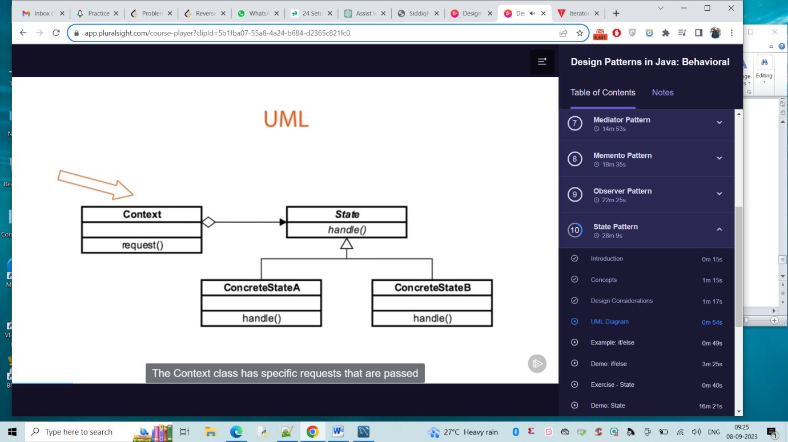Context class has specific requests that are passed through State (is interface ). Concrete states are there . We can remove multiple if else and can use states . Which can reduce cyclometric complexity

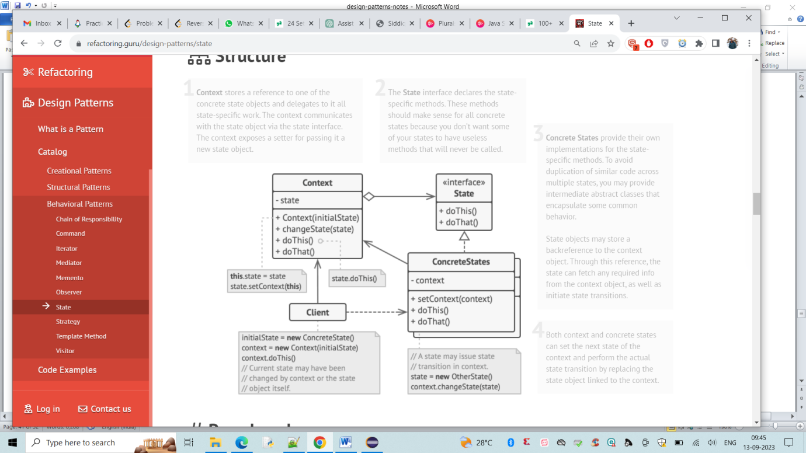

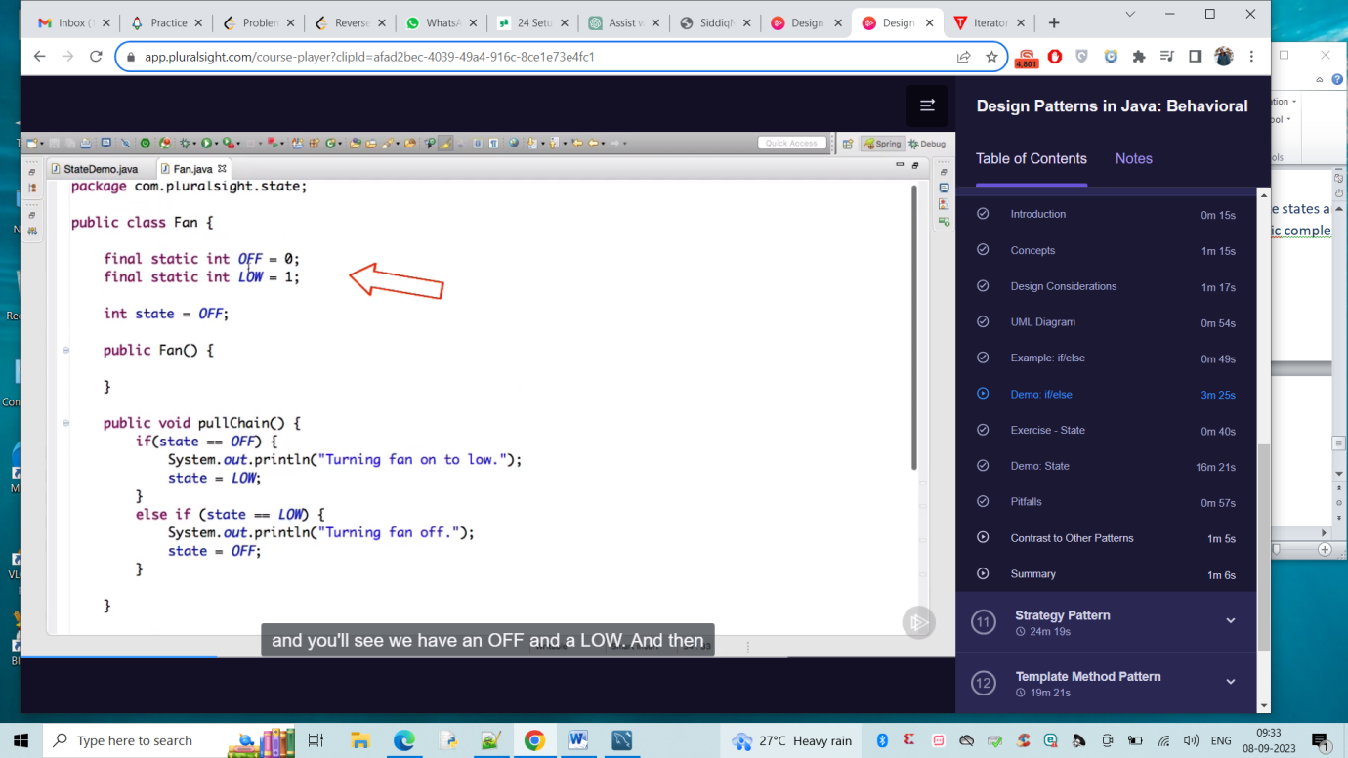

Instead of else if and if conditions ,we can create a concrete class and use functions of setoff, setHigh and all to make it to state patern.

Pitfalls :-

We should know your states

More classes will be created

Careful of keeping logic out of context.

We should identify state change triggers

Strategy Pattern:-

**Strategy** is a behavioral design pattern that lets you define a family of algorithms, put each of them into a separate class, and make their objects interchangeable.

Eliminates Conditional Statements

Behaviour encapsulated in classes

Difficult to add new strategies

Client aware of strategies

Client chooses strategy

In state pattern-> class per state, but here class per algorithm

API :-

Java.util.Comparator

Design :-

Interface or abstract base class

All remaining concrete class per strategy

Removes if/else conditionals

Strategies are independent

UML :-

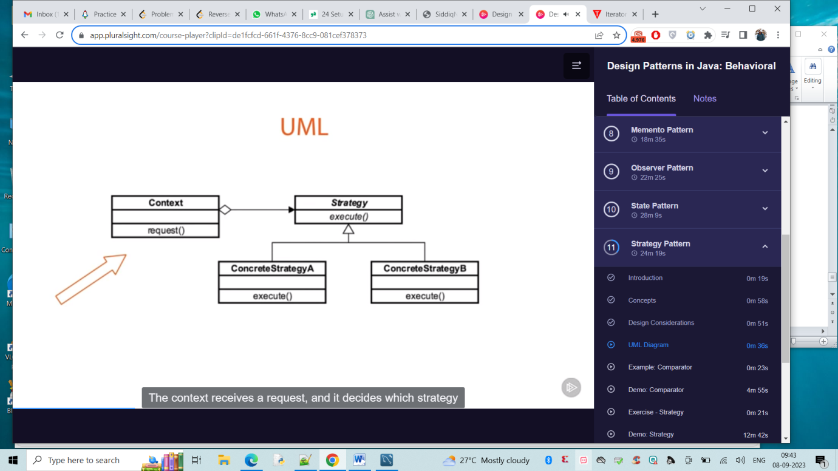

The context receives request and decides which strategy to use . Strategy adhere to same interface but strategy are different based on request received.

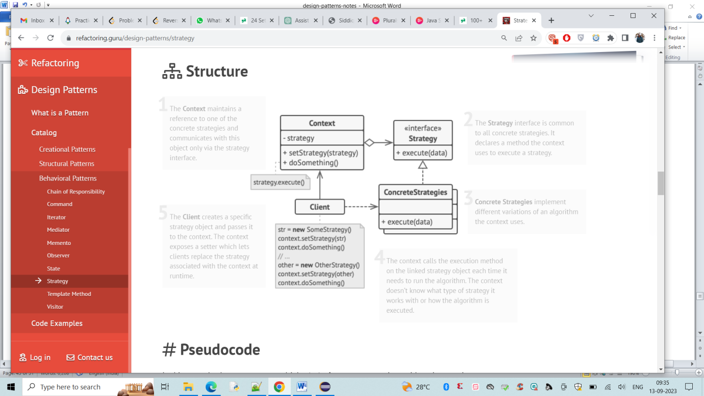

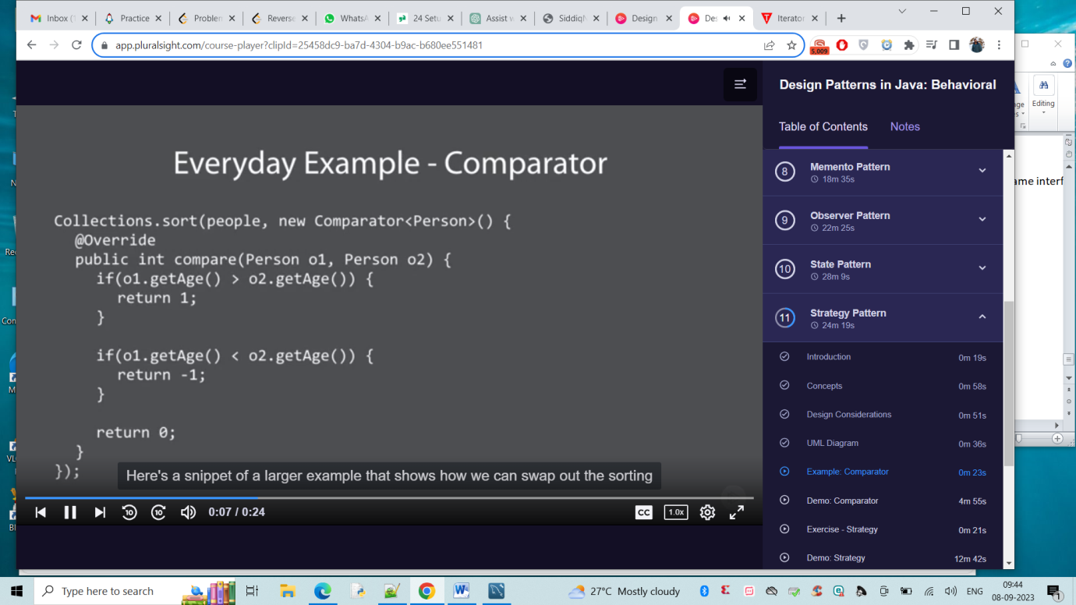

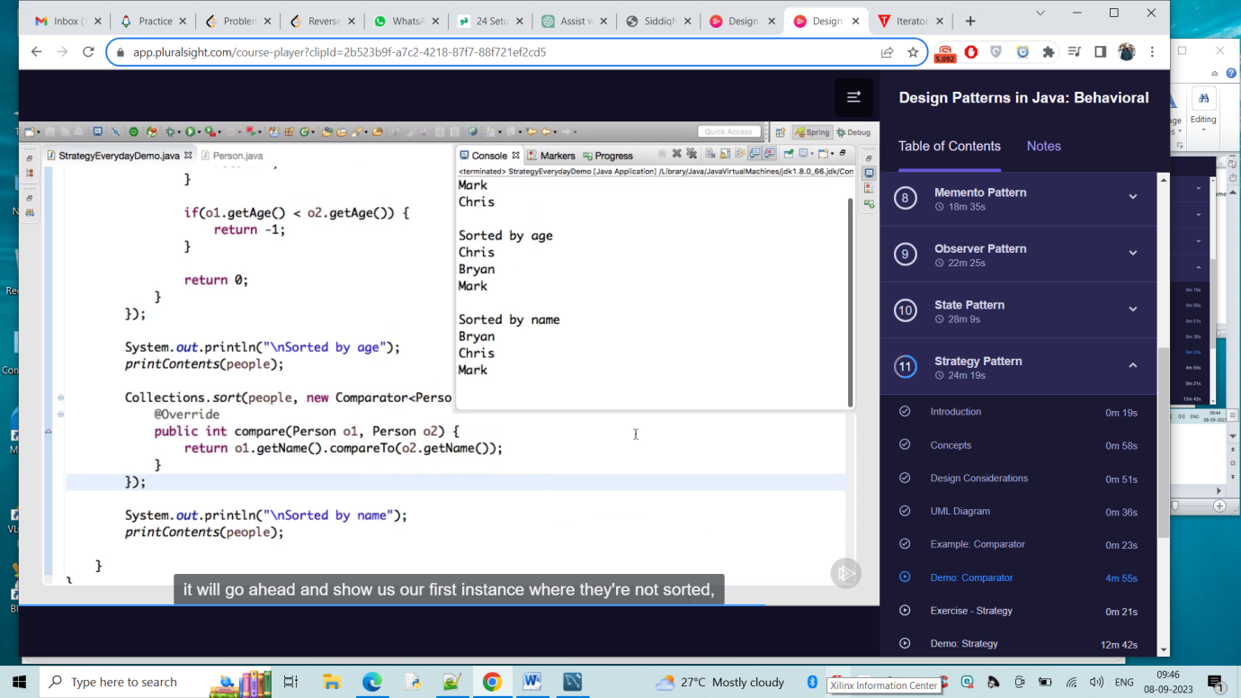

Pitfalls :-

Client should be aware of strategies

Increased number of classes

Class per algorithm

Template Method:

**Template Method** is a behavioural design pattern that defines the skeleton of an algorithm in the superclass but lets subclasses override specific steps of the algorithm without changing its structure.

Code reuse

Common in libraries/frameworks

IOC frameworks keep this pattern as main one

Algorithm Emphasis

Examples :-

Java.util.Collections#sort() -> same like strategy pattern

Difference here is strategy allows to swap out entire comparator, where template method focusing on method to override on sorting.

Java.util.AbstractList#indexOf()

Design:-

Difference between template and strategy is

template is same algorithm , class based, compile time

strategy is algorithm per class, interface based, Run time

Abstract base class

Base class calls child

Hooks are put in place

Operations though are put in place and must be overridden.

UML:-

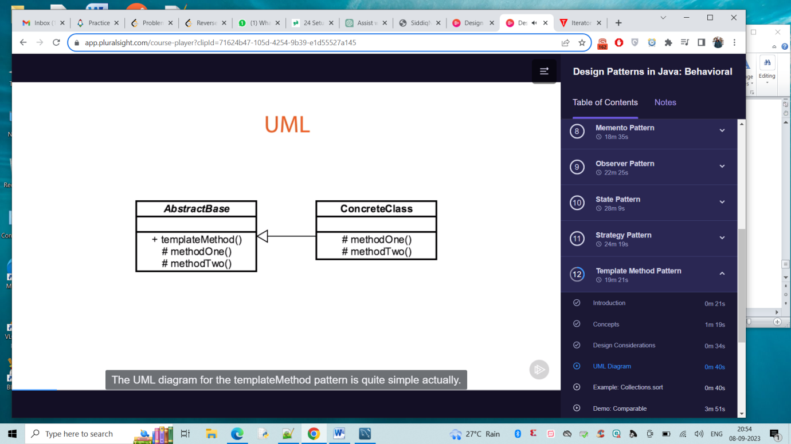

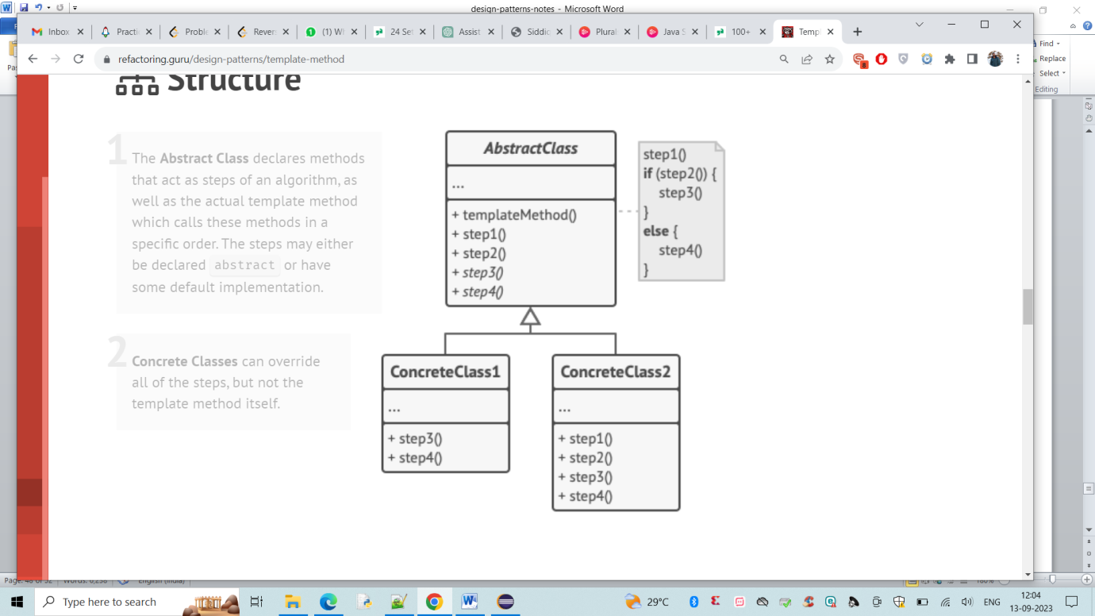

Abstract base class contains entry point i.e the template method which is called by client . It contains Operations and must be overridden by concrete class

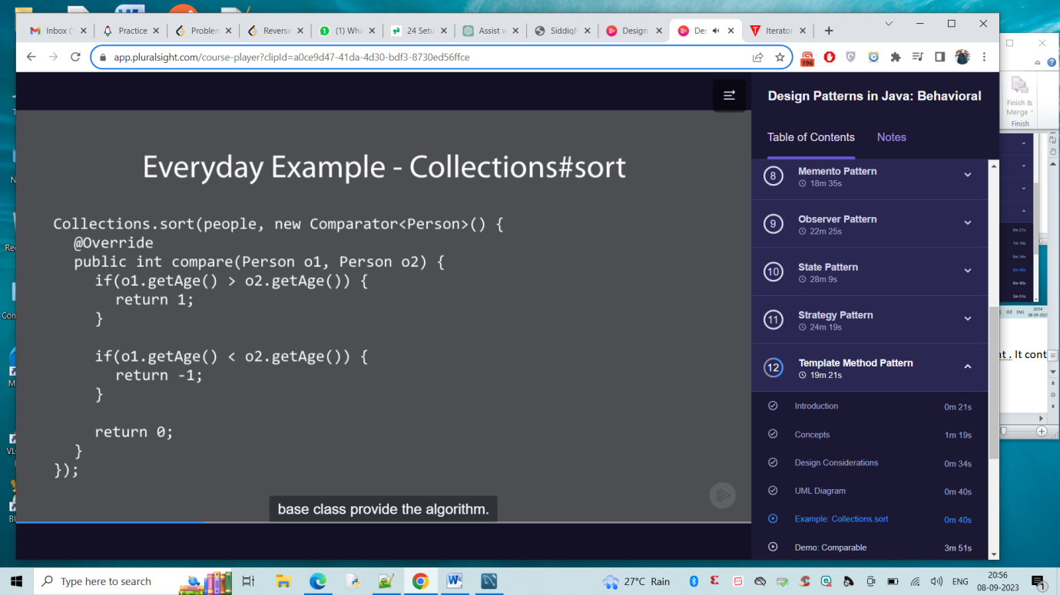

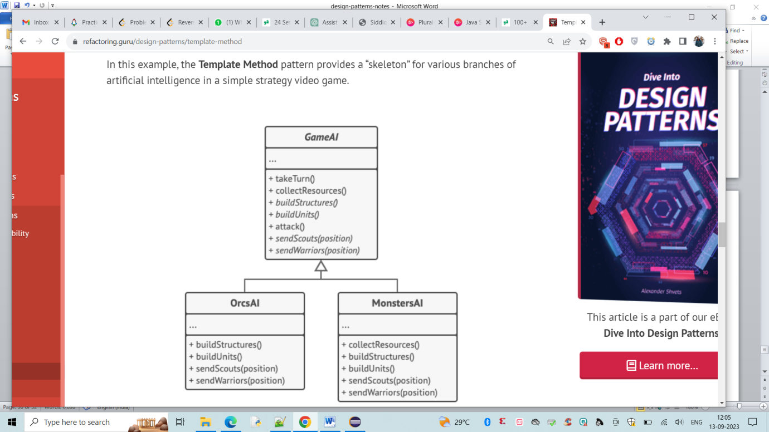

Pitfalls :-

We need to make sure that Restrict access to particular methods

Confusing hierarchy

<https://refactoring.guru/design-patterns/template-method>

Code Sample:

public abstract class DataRenderer{

public void render(){

String data = readData();

String processedData = processData(data);

System.out.println(processedData);

}

public abstract String readData();

public abstract String processData(String data);

}

Visitor Pattern :-

**Visitor** is a behavioural design pattern that lets you separate algorithms from the objects on which they operate.

Separate algorithm from Object

Adding new feature

Helps us maintain open/closed principle

Expect changes & add minor more complexity & externalizes change

Visitor changes

API :-

Java.lang.model.element.Element

Java.lang.model.element.ElementVisitor

Design :-

Interface based

Visitor and Element

Elements have visit method

Visitor knows every element

UML:-

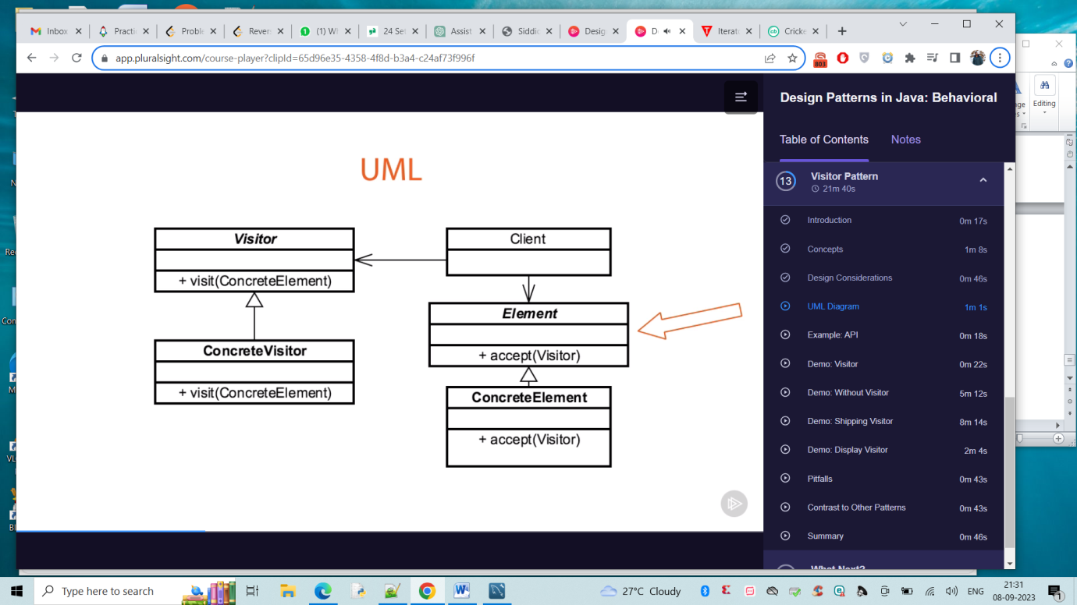

Client creates elements which are all instances of element interface. Elements are some form of concrete element. Instead of changing concrete element everytime that we want to add functionality, instead architect to have accept method on visitor. The visitor have a concrete element method for each type of element we interact with. Finally , we can have multiple concrete vistors.

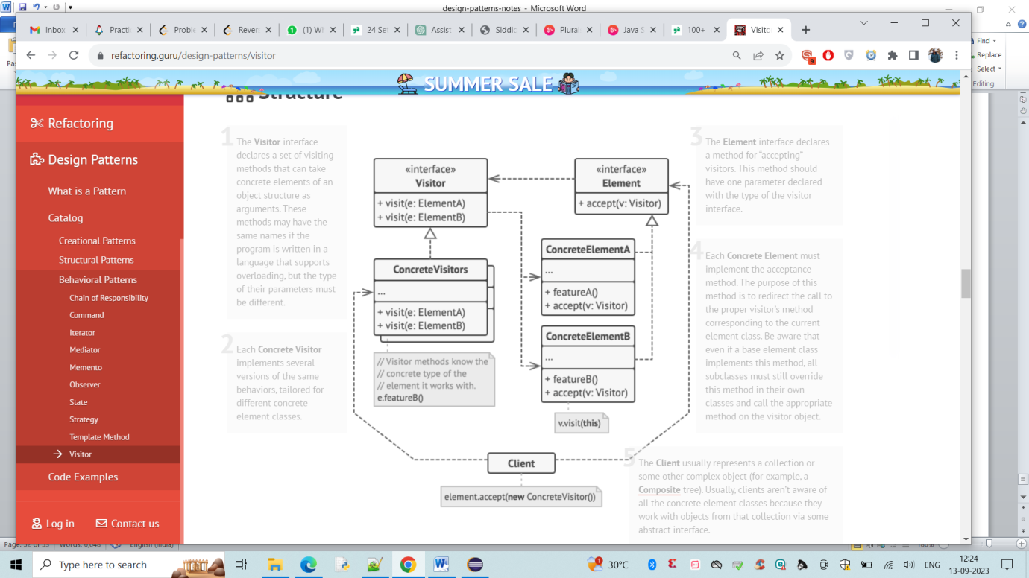

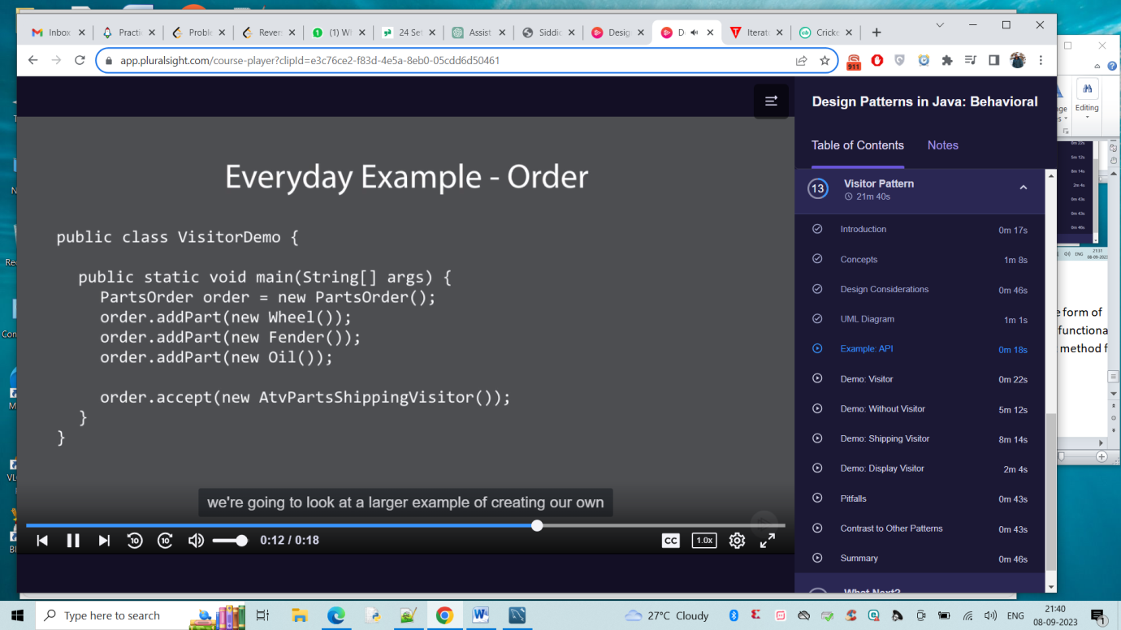

Pitfalls :-

We have to plan on adaptability

Indirection somewhat confusing

We might need to implement adapter pattern